AZURE TERRAFORM

**Aim**: - Create a Resource group, Azure storage account, Container and upload a blob on azure portal by using the terraform.

# **Create a Resource group, Azure storage account, Container and upload a blob on azure portal by using the terraform.**

To create app registration in azure portal

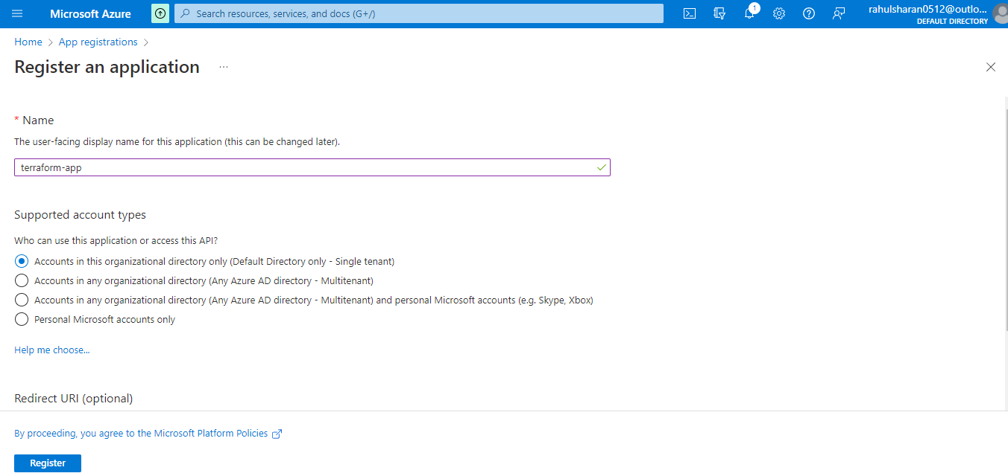

Successfully created application terraform-app.

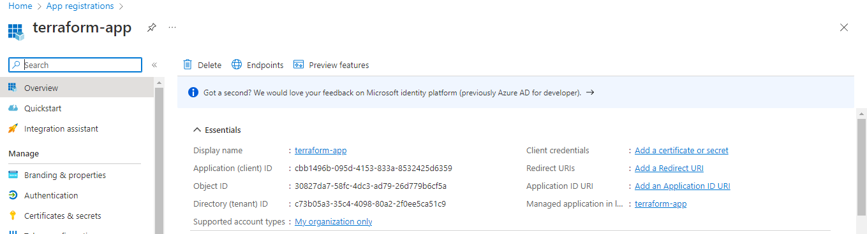

Create a client- secrets in application terraform-app.

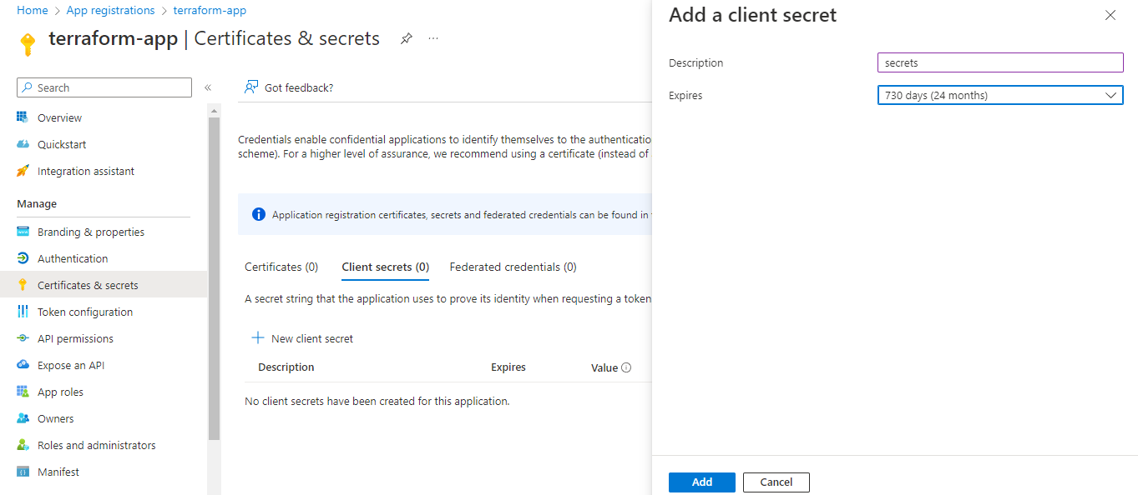

Successfully updated application terraform-app credentials

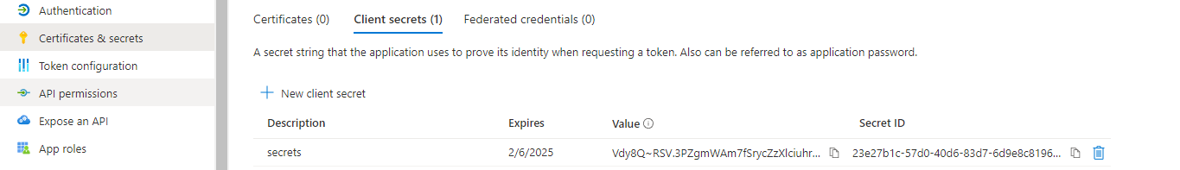

To add role assignment for terraform-app:

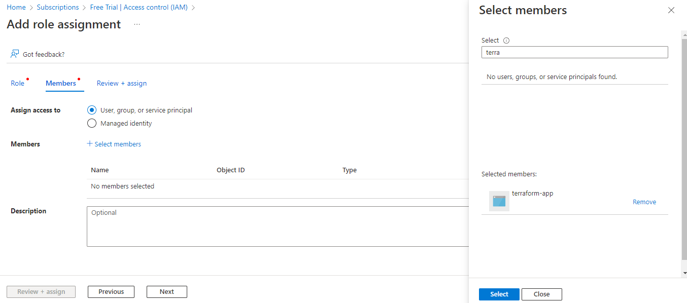

Terraform-app added as Contributor for Subscription (Free Trial).

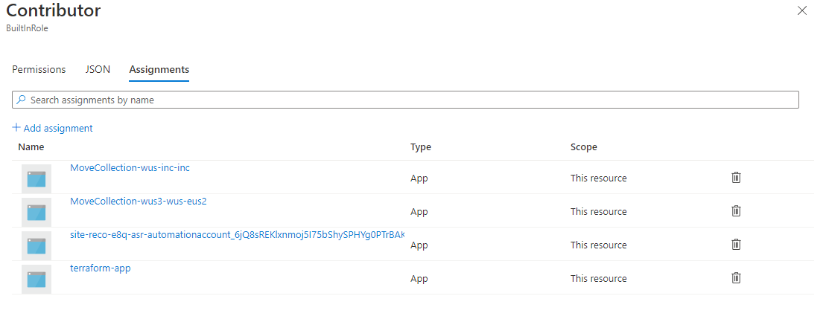

**Create a Resource group:**

Configure the resource group file by using the HCL.

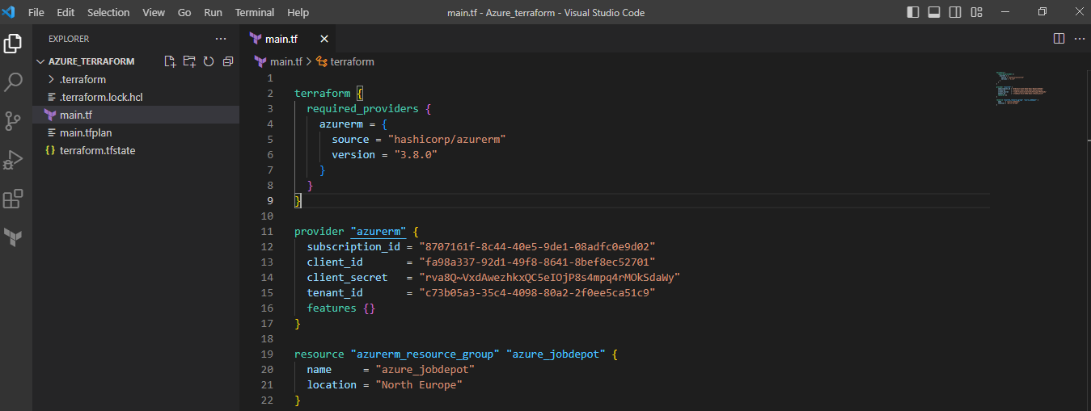

Initialize the terraform configuration file using the following command:

>terraform init

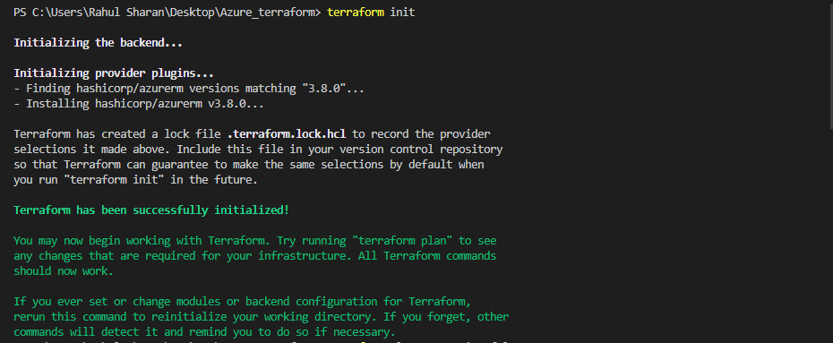

To create an execution plan for resource group by using the following command:

>terraform plan –out main.tfplan

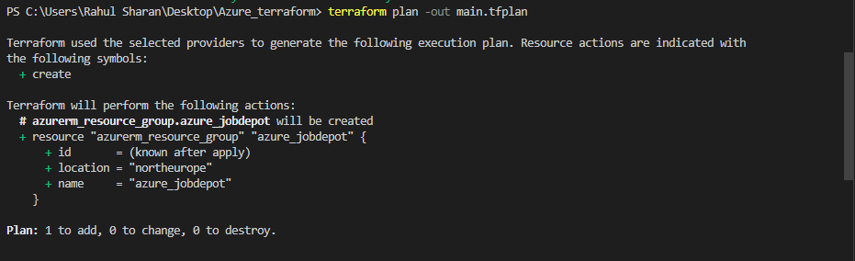

To execute the resource group by using the following command:

>terraform apply

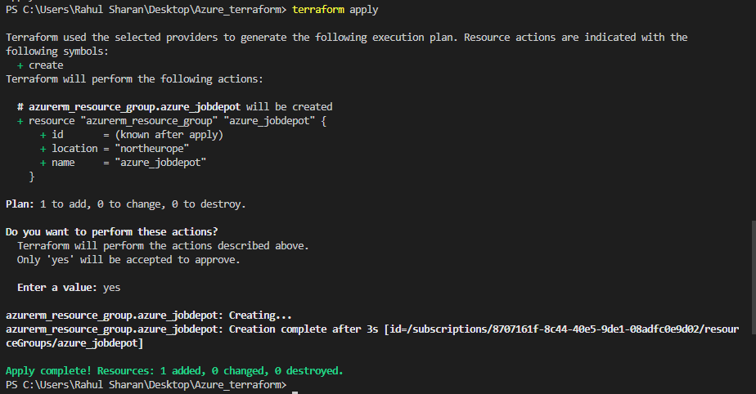

To verify the resource group in azure portal:

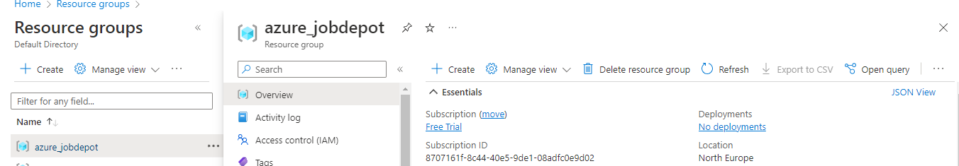

**Create a storage account:**

Configure the storage account file by using the HCL.

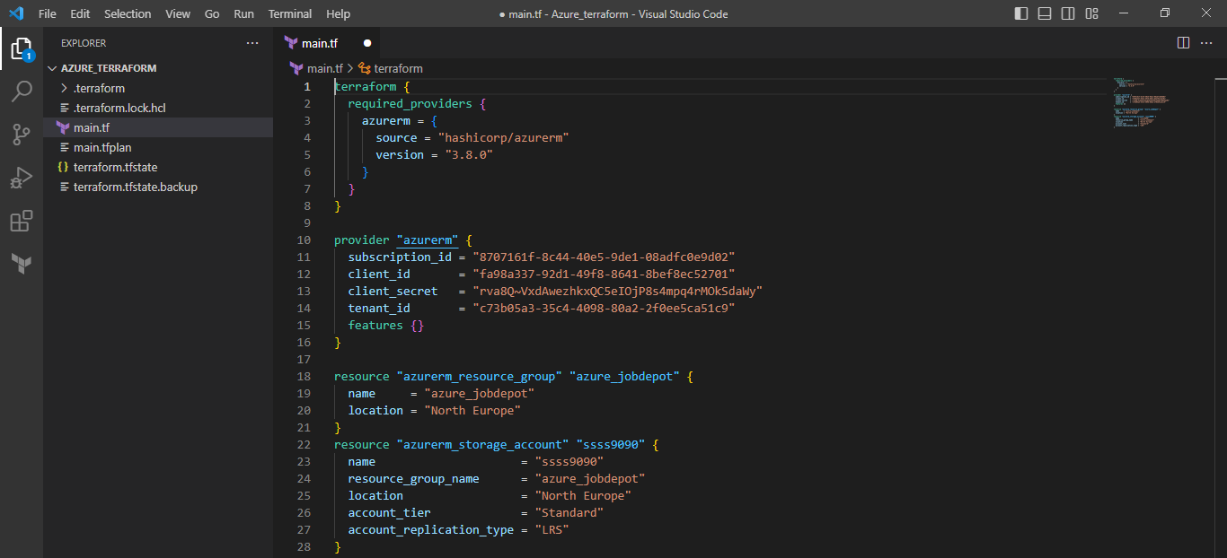

Initialize the terraform configuration file using the following command:

>terraform init

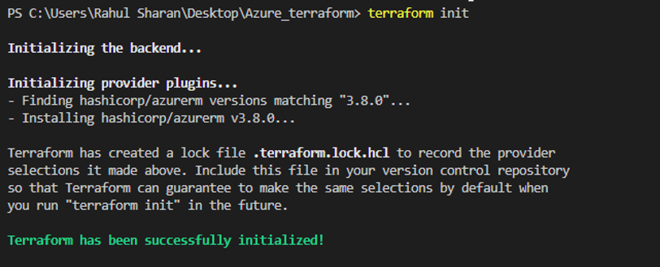

To execute the storage account by using the following command:

>terraform plan –out main.tfplan

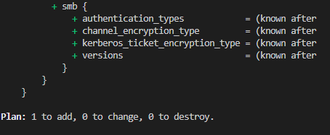

To execute the storage account by using the following command:

>terraform apply

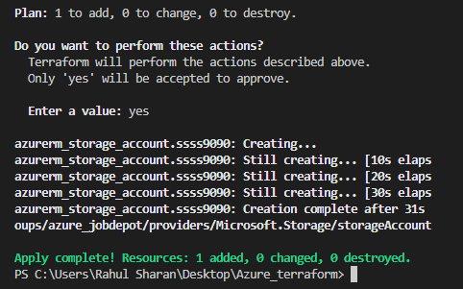

To verify the storage account in azure portal:

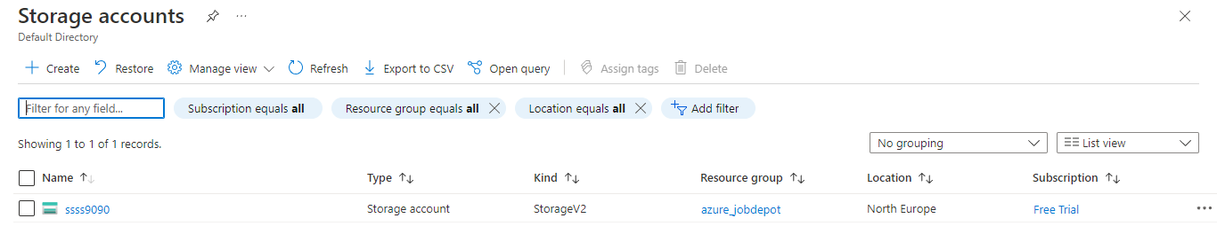

**Create a Container and upload a blob:**

Configure the container and blob file by using the HCL.

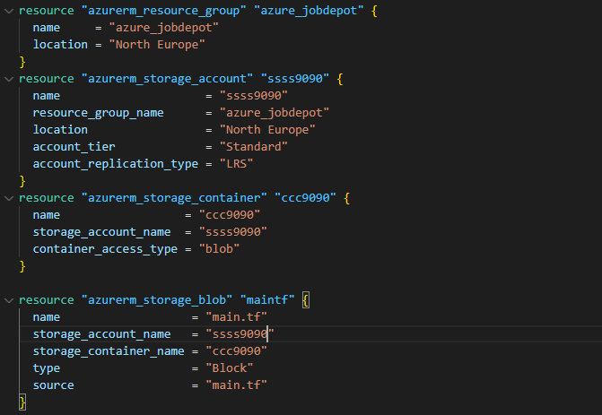

Initialize the terraform configuration file using the following command:

>terraform init

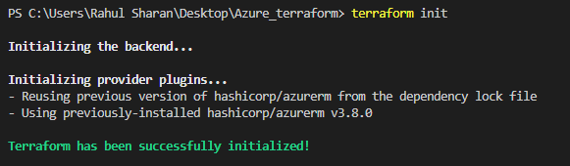

To execute the container and blob by using the following command:

>terraform plan –out main.tfplan

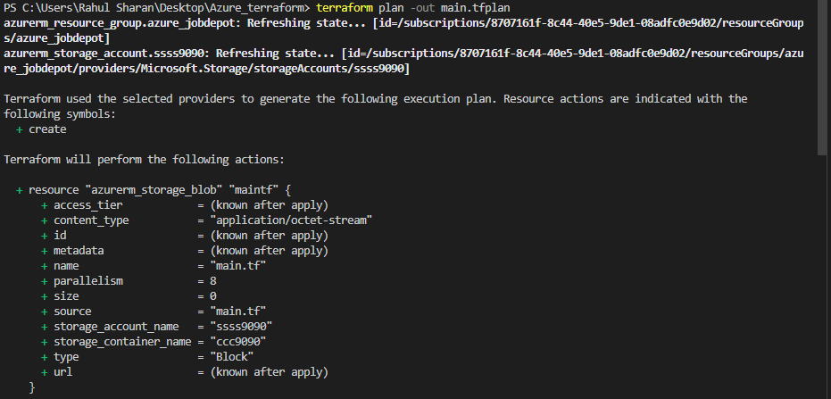

To execute the container and blob by using the following command:

>terraform apply

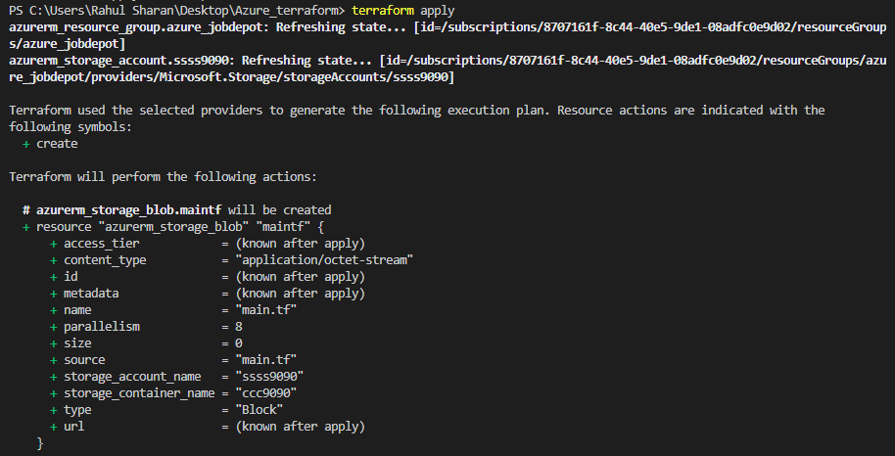

To verify the container and blob in azure portal:

